* Please find attached postman collection for testing



* Please find executable jar and command to run service

Run this command in command promt “java -jar cgi_test-0.0.1-SNAPSHOT.jar”



* API documentation, I have implemented swagger in my spring boot service. Please hit the below link to view swagger documentation.

<http://localhost:8080/swagger-ui.html>

Please refer below screen shot.

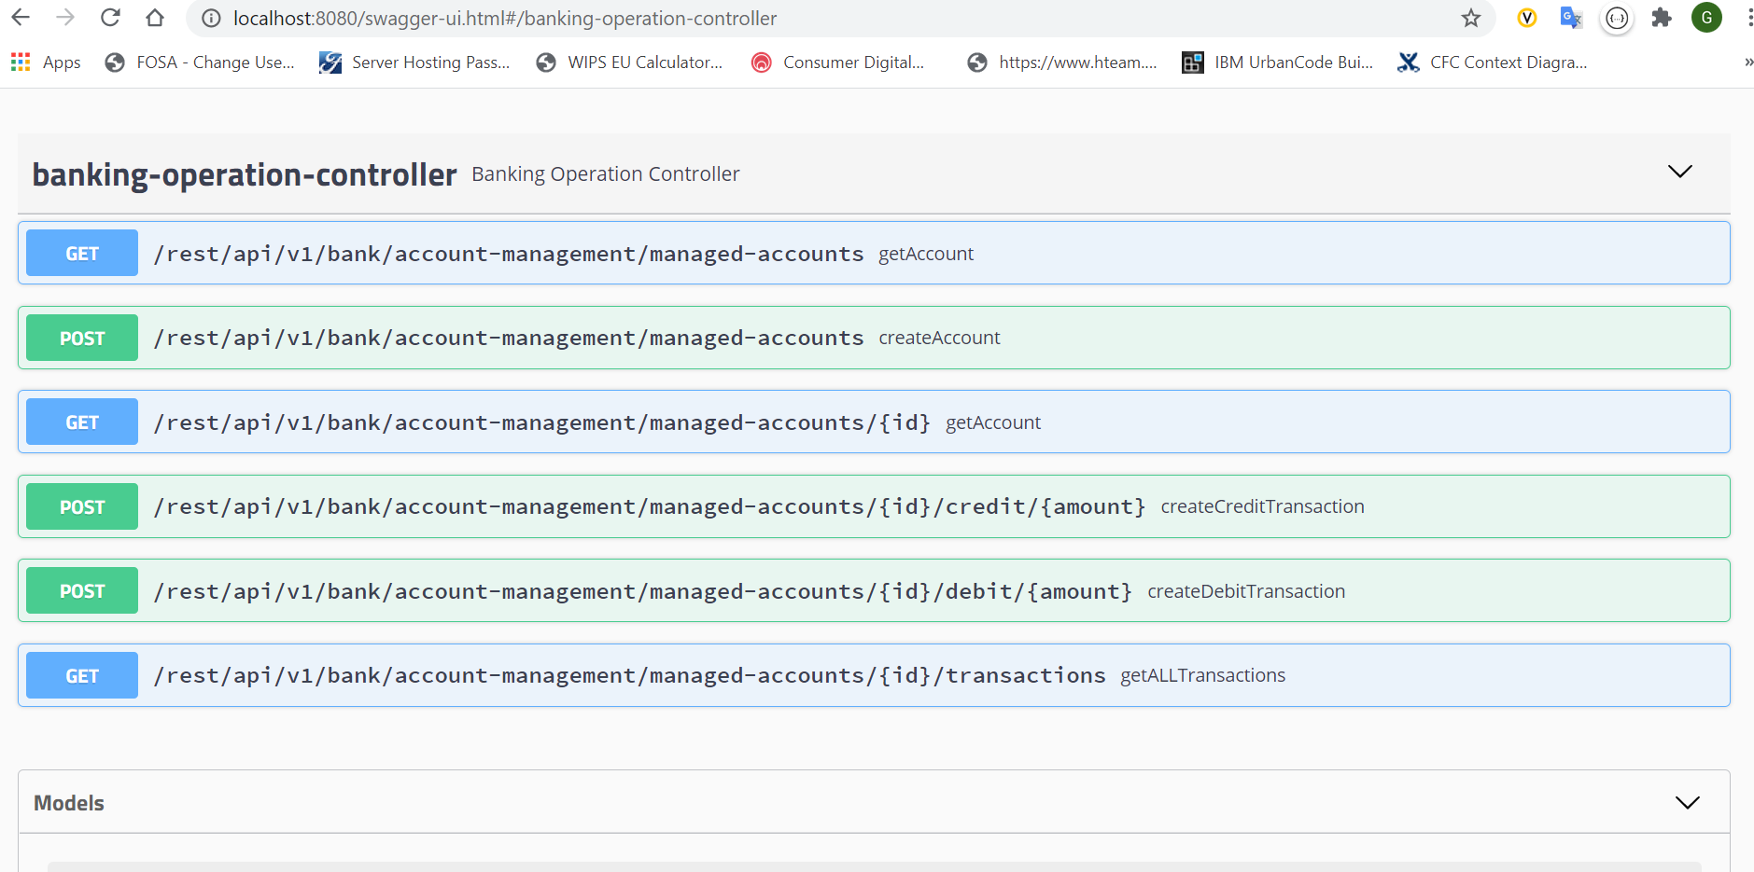

* Please refer below screenshot for test coverage and testcase results

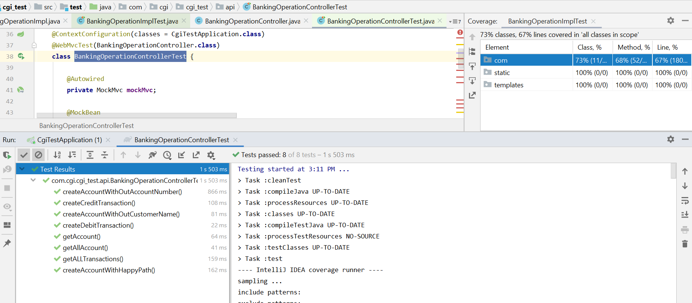

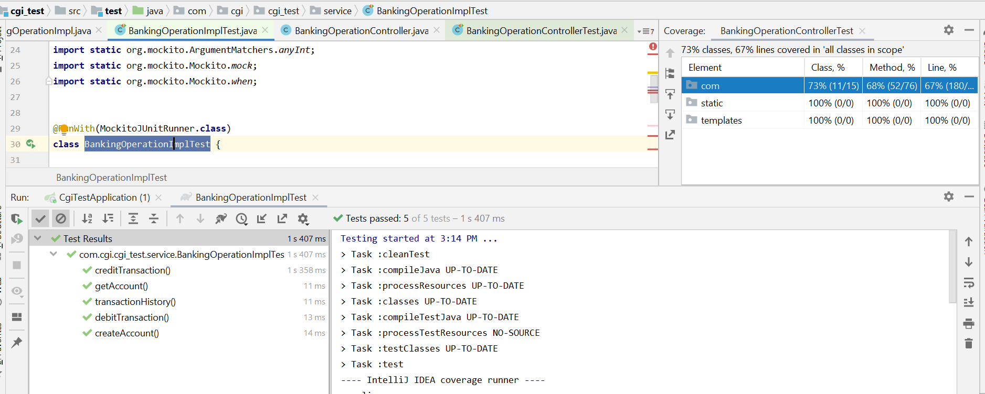

Please refer below postman screenshots for your reference

1. Create Account

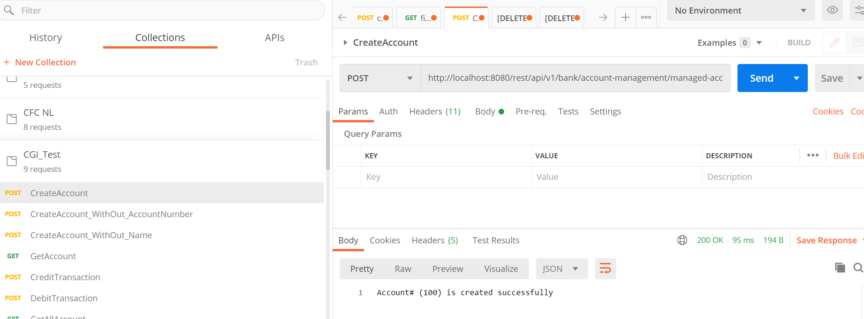

1. Create Account Without Account#

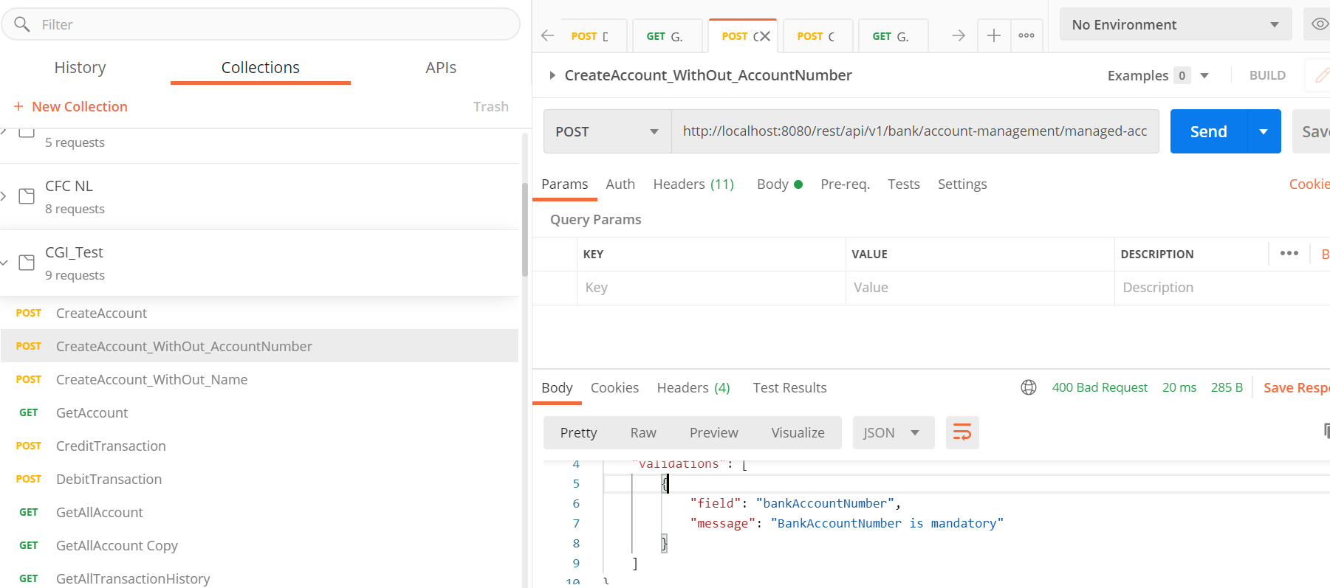

1. Get Account with Account No (<http://localhost:8080/rest/api/v1/bank/account-management/managed-accounts/1000>)

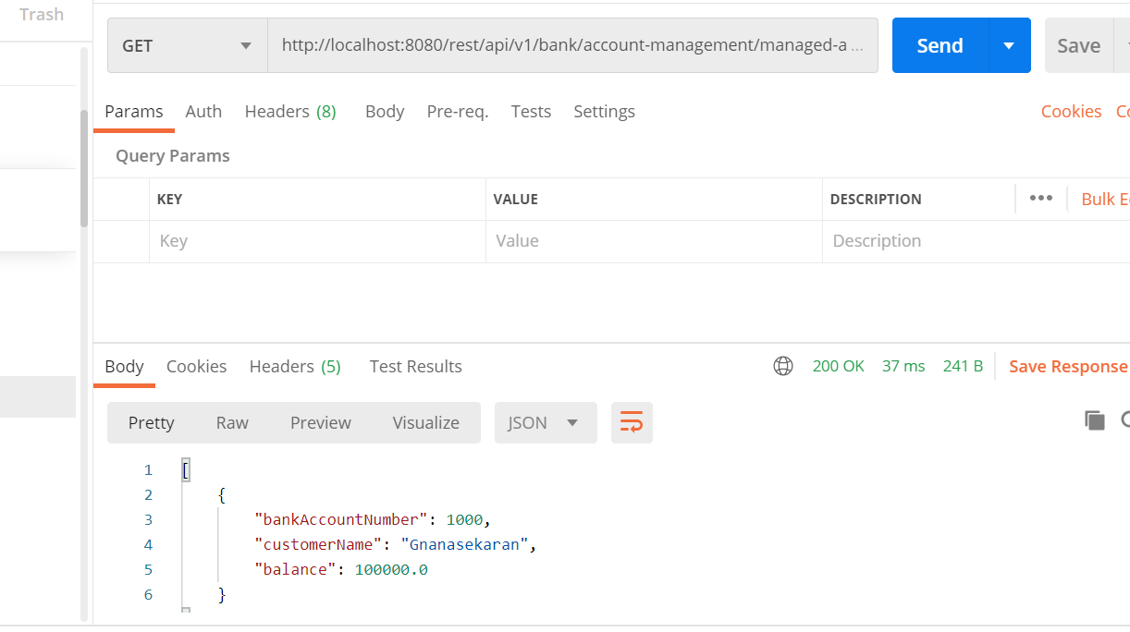

4 Get All accounts (<http://localhost:8080/rest/api/v1/bank/account-management/managed-accounts/>)

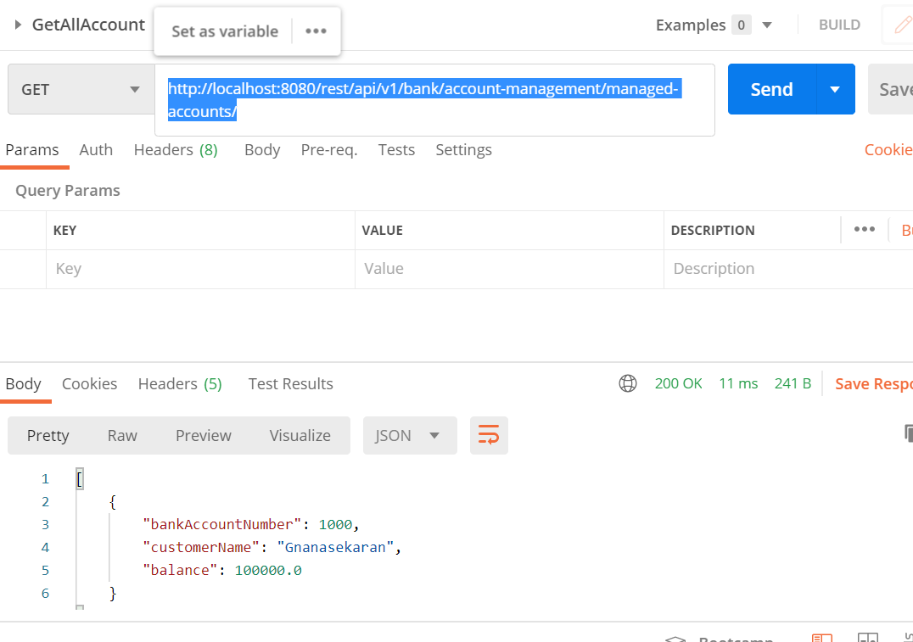

5 Credit Transaction (<http://localhost:8080/rest/api/v1/bank/account-management/managed-accounts/1000/credit/3000>)

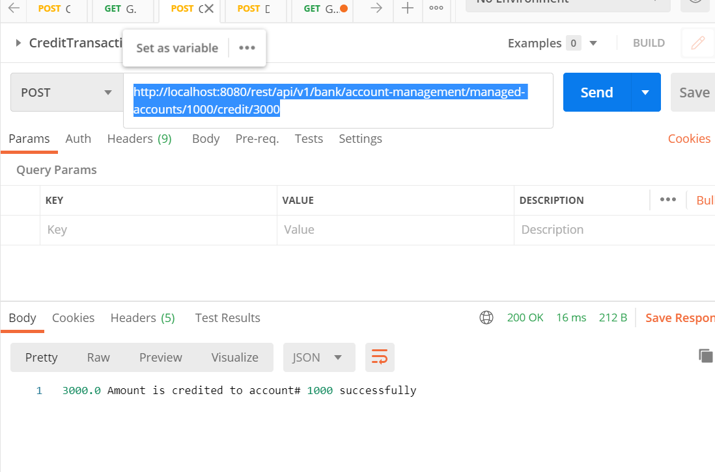

6 Debit transaction (<http://localhost:8080/rest/api/v1/bank/account-management/managed-accounts/1000/debit/100>)

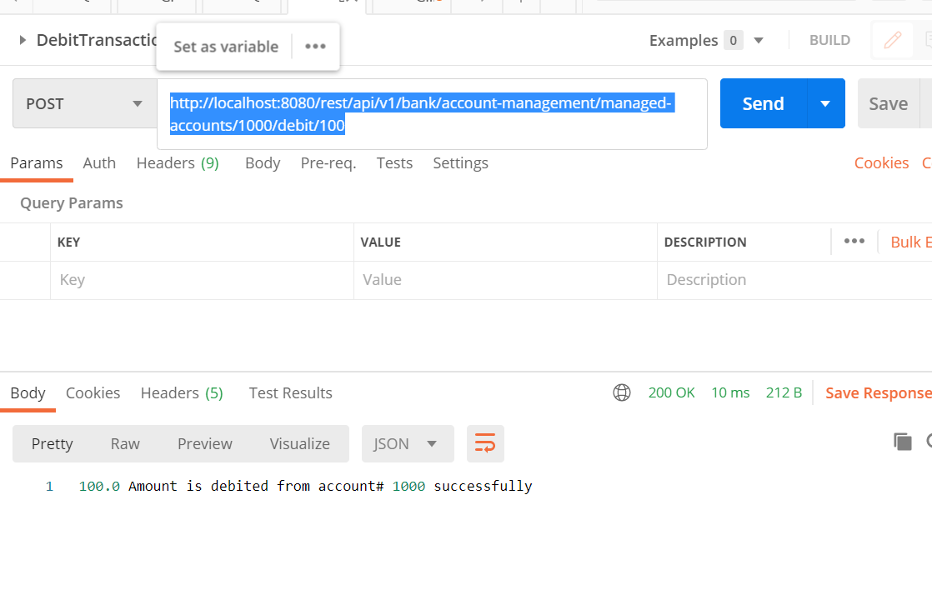

6 TransactionHistory (<http://localhost:8080/rest/api/v1/bank/account-management/managed-accounts/1000/transactions>)

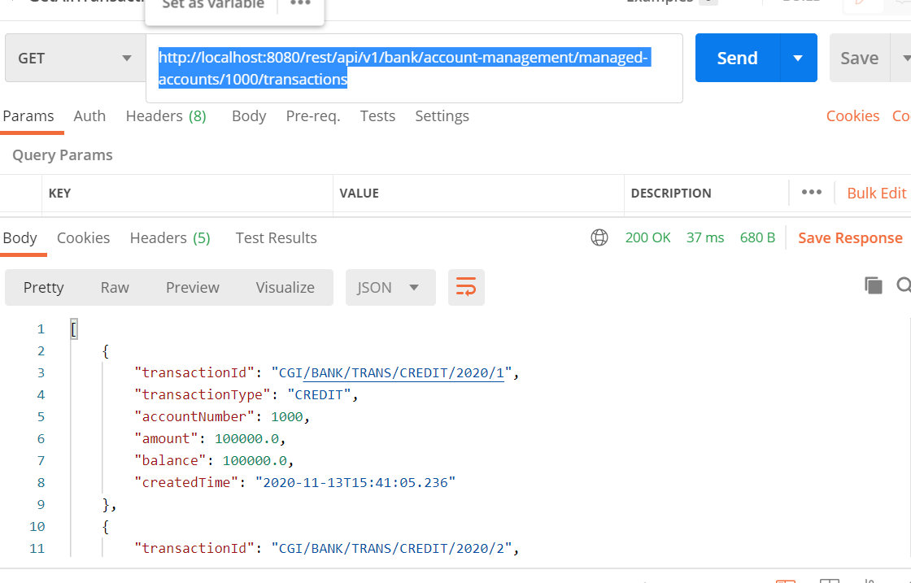

7 SpringBoot actuator is implemented for service health check management.